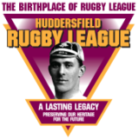 Theme 2 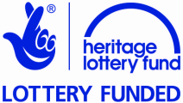

How Rugby Football Came to Huddersfield:
Developments that affected Rugby Football

Pupil Resource Sheet

Source A

Huddersfield grew as a town mainly because of the woollen industry. By the 1700s the area had a growing woollen industry.

Raw wool came from sheep reared on the surrounding hills, where fast-running streams and soft water were ideal for washing it, ready for combing to align the fibres in one direction.

Making woollen goodsbegan as a cottage industry. People worked in their cottages, spinning and weaving the wool by hand.

Inventions, such as the spinning jenny, first used in Huddersfield in the 1790s, changed the wool trade for ever. Such machines could spin and weave more quickly and cheaply than the cottage workers. It put them out of business, forcing them to look for work in the spinning and weaving mills in the town.

Many cottage workers had also fed themselves by raising animals and growing crops. In the 1700s, landowners began to enclose land – fence it off – partly to rear sheeptosupply wool for their mills. This made it harder for people to feed themselves, also forcing them into the towns to find factory work. Maps show that much of the farming land around Huddersfield was enclosed between 1720 and 1780.

Other industries, related to the woollen trade also grew. Chemical works supplied dye for clothing and iron foundries built the spinning and weaving machines. The machinery of all these industries was powered by coal from local mines and/or water.

A number of Huddersfield’s factories made worsted – compact, tough wool fibres such as that used in carpets.

With no organised public transport, rows of terrace houses were built close to factories so that the workers could live nearby. Areas such as Bradley Mills and Rashcliffe (Lockwood) grew in this way. The number of people living in Huddersfield increased quickly, asthe following table shows:

Year | Population | Year | Population
1700 | less than 1000 | 1851 | 30,880
1801 | 7,268 | 1861 | 34,877
1811 | 9,671 | 1871 | 38,654
1821 | 13,284 | 1881
1831 | 19,035 | 1891
1841 | 25,068 | 1901 | 95,047

By 2001 Huddersfield’s population had grown to about 150,000.

The people of the growing town also needed leisure time activities. With lots of people living close together, team sports became popular. People started to support teams that carried the name of their town or district. Such teams helped to give people a shared interest, a sense of identity, and a feeling of belonging to their town. They felt proud and happy when their team was successful against teams from other places.

Source B

In 1847 Parliament passed the ‘Ten Hours Act’, reducing the number of hours worked by women and children to ten per day.

It was followed in 1850 by a Factory Act that reduced the hours worked by men, so that work in most industries stopped at 2pm on Saturdays.

In 1884, the Mayor of Huddersfield, Alderman Wright Mellor said that before the 1850 Factory Act:
‘… the people had to work so many hours that after they got up early in the morning and worked until late at night they wanted no recreation – only food and rest. The Factory Bill had so altered things …’
After the 1850 Factory Act was passed, Moses Heap, a mill worker, wrote:
‘...we did not know how to pass our time away. Before it had all been bed and work; now in place of 70 hours a week we had 55½ hours. It became practice, mostly on Saturdays, to play games, especially football and cricket, which had never been done before.’

The number of sports teams in Huddersfield grew quickly between the 1850s and the 1880s.

By 1880 the Huddersfield Rugby Football Club was the town’s main winter sports’ team, and supporting them became a passion for local men.

Source C

Huddersfield had a local postal service from the late 1700s. By 1830 the town had a post office in New Street. This post office became much busier when, in 1840, the Penny Post began. There was now a system for sending letters to anyone anywhere in the country, making it much easier to communicate with people in other towns.

This postal system was already in place when the first rugby football clubs, such as Huddersfield, were founded. It allowed secretaries to communicate with:
- landowners and builders about setting up and developing their grounds such as Fartown, and club buildings, such as the St John’s gymnasium, headquarters for the Huddersfield Cricket and Athletic Club from 1875
- secretaries of other clubs to arrange matches
- the organisers when competitions began, such as the Yorkshire Cup (1877), Yorkshire Senior Competition (1892) and, for Huddersfield’s local amateur clubs, the Holliday Cup (1885)
- players from other places whom they might want to sign to play for their club.

Source D

All industrial towns need good transport routes to transport raw materials such as wool, coal and iron, and finished goods such as cloth and machinery.

In 1780 Huddersfield was connected by canals and rivers to Leeds, Wakefield and on to the Midlands. In 1811 the Huddersfield Narrow Canal was opened, connecting with other canals to provide a route through the Pennines from West Yorkshire to Manchester and Liverpool.

Road transport was also developing. The first two turnpike roads for horses and horse-drawn carriages in the Huddersfield area were finished in 1759. They ran from Dewsbury to Elland, and from Wakefield via Marsden to Austerlands on the Lancashire border. Many more were built over the next 100 years, including roads to Leeds (1765), Halifax (1777), Rochdale (1805), Penistone (1824) and Bradford (1840). The Manchester Road to Marsden was cut through the Colne Valley in 1820.

In 1837 a Board of Highway Surveyors began to check and repair the roads.

In 1858 a horse bus service (below) began along Bradford Road. By 1873 there were horse bus services to Lockwood, Lindley, Edgerton and Moldgreen.

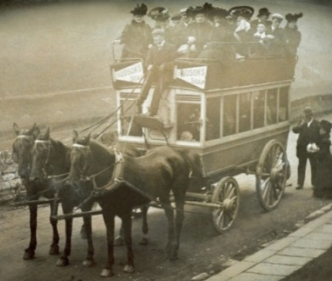
In 1883 Huddersfield became the first local authority to run its own public transport system. Tramcars pulled by steam engines ran on local routes. The tram system was electrified in 1901.

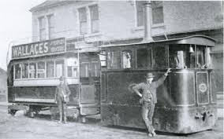
Steam Tram

Meanwhile, journeys to other towns became much faster after the railway came to Huddersfield. Huddersfield Railway Station was opened in 1847. The number of rail routes increased as lines were completed.

Later the railway was used to transport players and supporters to rugby and football matches.

Transported by canal, road and rail, Huddersfield’s woollen goods were sold at markets across Britain. They were also taken to ports to be shipped and sold abroad.

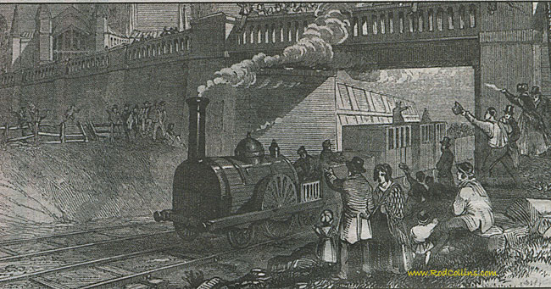
Early steam train

Source E

As the number of people living in Huddersfield increased, new buildings, organisations and services for the community appeared.

Huddersfield became a county borough with its own corporation, able to run its own affairs, in 1868. In 1920 the borough bought most of the land in the town centre from the Ramsden estate for £1,300,000. The corporation of 1868 was able to build on services that already existed.

Huddersfield had its first gas street lighting in the 1820s. Electric street lights, invented in 1881, were phased in after World War I.

Huddersfield’s first piped water supply was pumped from the River Colne in 1743. It was expanded when reservoirs were opened at Longwood (1828), Deerhill (1875) and Blackmoorfoot (1876).

Open sewers ran in ditches along the sides of the streets until the 1820s. Sewage collection improved a little in the 1830s. A much improved sewage system was introduced in 1872.

Huddersfield’s first policemen were appointed in the 1820s. They had a police house and lock-up (prison cells) in 1831. In 1898 a new police station was opened in Peel Street. By then the town had 113 police officers.

The County Court was built in 1825. This building is still there, next to the Lawrence Batley Theatre.

In the 1850s and 1860s most of Huddersfield’s wide, handsome streets, including St Peter’s Street, Northumberland Street, Byram Street and John William Street were laid out. Most of their impressive buildings, including the George Hotel (1851) and the Lion Building (1854) were built at the same time.

Public buildings of which local people were proud included Huddersfield Town Hall, built in two stages and completed in 1881.

The town also needed hospitals. Huddersfield Royal Infirmary opened in 1831. Other places of care included Bradley Wood Sanatorium, opened in 1870, and St Luke’s Hospital, opened in 1872.

Many of Huddersfield’s churches were built between 1810 and 1860, including Holy Trinity Church (1819), St Paul’s (1829), and the parish churches at Golcar, Lindley, Linthwaite, Paddock and South Crosland. The town’s largest cemetery was opened at Edgerton 1855.

After five local banks failed in Huddersfield in the early 1800s, the gap was filled by a public company, the Huddersfield Banking Company. Founded in 1827, it was the first joint-stock bank in Yorkshire, and one of the first in England. The Head Office was in Cloth Hall Street. This bank merged with the Midland Bank in 1897.

The University of Huddersfield can trace its origins to the formation of the town’s Philosophical Society in 1825. In 1841 this society became the Mechanic’s Institute, which had a library, a reading room which included the latest newspapers, and ran lectures and education classes for adults. The Mechanics Institute, along with the Chamber of Commerce, set up the Huddersfield Technical School and Mechanics Institute in 1881. This became the Huddersfield College of Technology in 1958, Huddersfield Polytechnic in 1972 and the University of Huddersfield in 1992.

Source F

In 1870 Parliament passed an Education Act which resulted in more children spending longer at school.An 1880 Act meant that all children had to go to school at least until the age of ten. By the early 1880s there were many more adults who could read.

This was good for the sales of local newspapers. As today, the local newspapers reported events at local sports’ clubs such as the Huddersfield Rugby Football Club. There was a healthy two-way relationship between the football club and the newspapers. Sport helped to sell newspapers, and newspapers helped to develop and maintain interest in the sports clubs.

The first local newspaper was the Huddersfield Weekly Chronicle, published in 1850. The longest running local newspaper, the Examiner, was founded in 1852 as the Huddersfield Weekly Examiner.

Source G

The first ever collectable cards were made in Bradford in 1886. They were called Baines Cards after the man who invented them, John Baines.

They featured famous cricketers, footballers, athletes, rugby players and teams, such as the Huddersfield and Underbank rugby football clubs on the cards below.

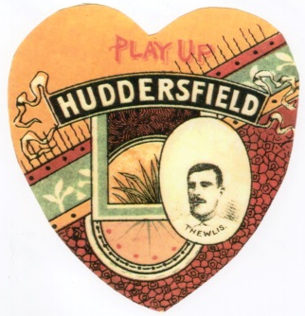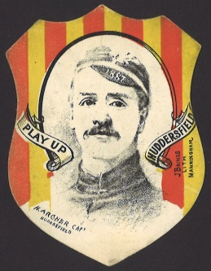

Such cards indicate the high level of interest in rugby football and its clubs.

Source H

In 1837 Sir William Fothergill Cooke and Charles Wheatstone sent a code of electrical signals down a wire across London, spelling Britain’s first telegraph message. At the same time in America, Samuel Morse was developing a similar system using his Morse Code alphabet.

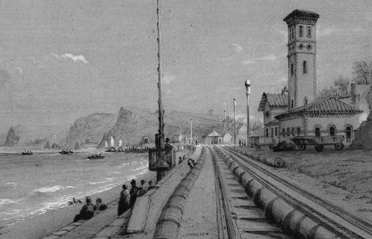
Telegraph wires sealed in atmospheric tubes alongside a railway track

By September 1847 sixty places in England and Scotland had a telegraph office which could send and receive messages. These included Huddersfield.

Huddersfield’s electric telegraph office was in John William Street, close to the railway station. It made communication with other places much faster. When organised sport began to take off, it helped secretaries to organise builders and materials as grounds were being built. Huddersfield’s Fartown ground was developed for rugby football and opened in 1878. It was so impressive that it hosted an FA Cup semi-final in 1882. The ground was further developed in 1890 when £5000 was raised by selling 5000 £1 shares.

The electric telegraph also helped club secretaries to arrange matches and to sign players from other places.

By the 1890s, when Huddersfield played away from home, scores were pinned up close to the telegraph office for people to read, helping to develop interest in supporting the team.

On the evening of Tuesday 14 November, 1893, hundreds assembled by the electric telegraph office. They were awaiting news from a meeting of the Rugby Football Union in London. This meeting was considering whether Huddersfield had broken the rules by paying and finding work for two players they had just signed from Cumberland. The telegram arrived at 10.30pm. Huddersfield had been found guilty and banned from playing any matches until the end of 1893, a total of eight matches.

Source I

As the town of Huddersfield grew, local people formed groups which organised leisure activities.

Through the 19th century (1800s) numerous choirs, orchestras and bands were founded in Huddersfield and the surrounding district.

The Huddersfield Choral Society was founded in 1836 and is still going strong today.

The Huddersfield Glee and Madrigal Society – now the Huddersfield Singers – was founded in 1875.

The Annual Mrs Sunderland singing competition has been held since 1889.

Several brass bands also survive from the 1800s.

Formed in 1843, the Skelmanthorpe Band is one of the oldest brass bands in the country.

Meltham Mills Band was formed in 1846. They won their first British Open Championship at Belle Vue in 1873. The band was the first to win the British Open title in three consecutive years – 1876 to 1878. Only five bands have ever achieved this.

Emley Brass Band was founded by local coal miners in 1870. Hepworth Brass Band can trace its origins to 1882.

The Brighouse and Rastrick Temperance band – now the Brighouse and Rastrick Brass Band – was founded in 1881 and for much of its history has been one of the outstanding bands in the country.

Marsden Silver Prize Band began as Holme Mills Brass Band in 1889.

The current Slaithwaite Brass Band was formed as Slaithwaite Brass and Reed Band in 1892, although a number of other bands were founded in Slaithwaite from the early 1800s.

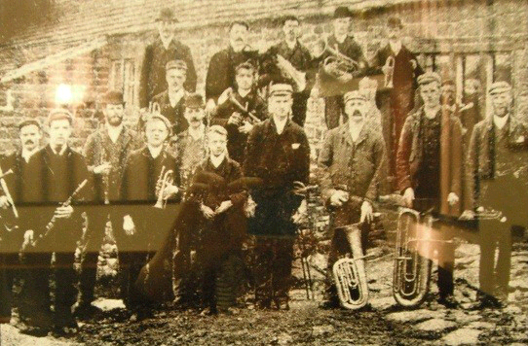Slaithwaite Brass and Reed Band 1892

Some of Huddersfield’s early theatre entertainment – mainly plays and music hall variety shows – tookplace in the Philosophical Society’s lecture hall, opened in Ramsden Street in 1841. In 1859 this hall was converted into a theatre - the Theatre Royal. It joined the Cambridge Music Hall, opened in 1857 in Upperhead Row, as a place of entertainment. The Cambridge Music Hall closed in 1869.

Rowley’s Empire was opened by variety entertainer JW Rowley in 1886. Along with live entertainment, it was also the town’s first cinema, showing silent films from 1896 until it was demolished in 1904.

A number of theatres and cinemas opened in the town in the early 1900s, including the Hippodrome in 1909, converted from the Riding School built in 1846.

Source J

The outdoors offered the cheapest and healthiest leisure-time activities for Huddersfield’s workforce, most of whom earned low wages in the 1800s.

Parks and Gardens
Land for public relaxation was opened at Greenhead in 1870 and at Sparrow Park – on the site of the current bus station – in 1873. Neither was an officiaI ‘park’.

Huddersfield’s first official public park, Beaumont Park, was opened in 1883. It was followed in 1884 by Greenhead Park and in 1896 by Norman Park in Birkby.

Flower shows were very popular in the 1800s. Huddersfield’s first floral and Horticultural Show was held on Rifle Fields – roughly the site of Greenhead Park – in 1865.

Animal Sports
Most of Huddersfield’s early sports featured animals. Wild boar hunting was an upper class pastime in the middle ages.

Bull-baiting and cock-fighting were fuelled by betting and popular with working men, even after cock-fighting was made illegal in 1835. There is a record of bull-baiting at Kirkburton in the 1750s.

Athletics, Cycling and Gymnastics
The Apollo Gymnasium was opened in Huddersfield in 1850. When it closed in the early 1860s its members set up the Huddersfield Athletic Club which hosted its first festival sports day at Rifle Fields on 24 June 1865. These annual events, which included: running, jumping andthrowing activities; gymnastics and cycling, continued into the 1890s. From 1876 they were held at Fartown, the club’s new home after it merged with the Huddersfield St John’s Cricket Club in 1875.

Cycling became popular after the boneshaker cycle was invented in 1868. More women started to cycle after gears and inflatable tyres were invented in the 1880s.

Cricket
Cricket is the oldest of the local team sports. Cricket and rounders were played in the streets and fields around Huddersfield for many years before the first cricket clubs were formed. The first cricket club in the district was Lascelles Hall, founded in 1825. In the 1870s Lascelles Hall provided more than half of the Yorkshire team.

In 1865, 20 cricketers of Huddersfield and District beat the All England Eleven by one run before huge crowds at Rifle Fields. Most local cricket leagues were founded in 1892 and 1893.

Swimming
The district’s first swimming pool was Slaithwaite Spa Baths, opened in 1825 by local businessman Richard Varley. A wide walkway led from the baths to the Bath Hotel on Lockwood Road. It was laid out as ornamental gardens. The hotel had a bowling green, a museum and a bandstand.

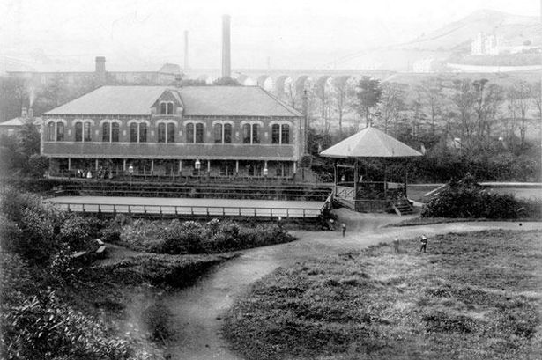
Slaithwaite Hall and Spa

Two years later, in 1827, Huddersfield’s first swimming pool, Lockwood Spa Baths, was opened. This was the home of Huddersfield Amateur Swimming Club when it was founded in the 1860s. The club transferred to the much larger Ramsden Street baths when they were opened in 1879. Swimming baths was opened on Cambridge Road in 1931. All are now closed – Lockwood Spa in 1946, Ramsden Street in 1972 and Cambridge Road in 1997.

Association Football
Although rugby football was the first popular local wintertime team sport, association football grew in popularity after the FA Cup was founded in 1871. The Huddersfield and District Association League was founded in 1898. Huddersfield Town FC was founded in 1908 and joined the Football League in 1910.

Bowls
Crown green bowls was widely played in the second half of the 19th century. The Bath Hotel in Slaithwaite had a green in the 1820s. An early green in Huddersfield was at ‘The Bowling Green’ public house in 1840.

Tennis
The Huddersfield Lawn Tennis Club, founded in 1881, was one of the first clubs in Yorkshire. They played on land near Halifax Road at Edgerton and within a year had about 180 members. The club still exists as Huddersfield Lawn Tennis and Squash Club.

Tennis was one of the first of the modern sports played by women.

Golf
Several golf clubs were founded around the turn of the 20th century. Huddersfield Golf Club, founded in 1891, had an 18-hole course for men and a nine-hole course for women. Outlane Golf Club was founded in 1906, Crosland Heath in 1914 and Woodsome Hall in 1922.

Indoor Sports and Games
There were billiards rooms at several public houses in Huddersfield by the 1860s. Some clubs in other sports had a billiards rooms in their club houses.

Huddersfield Chess Club was founded in 1852 by John Watkinson. In 1880 John founded the British Chess Magazine which is still published today. In 1895 the Huddersfield Chess Club organised the growing number of local clubs into a league competition.

Churches, Chapels and Sunday Schools
Churches, chapels and their Sunday Schools organised many activities for their followers, partly to keep them out of the pubs. Activities included sports, day trips on public holidays, music, drama and educational activities. In the 1870s Hillhouse Methodist Chapel offered billiards, snooker, darts, tennis and table tennis. Others founded cricket, rugby and association football teams.

Shared Interest and Pride in Teams encourages Sense of Community
By the year 1900 sports clubs were the largest group of new organisations.

People shared interest and pride in their local teams and this helped them to feel part of their community. They enjoyed a sense of achievement when their local team was successful. When Huddersfield Northern Union Rugby FC won the Yorkshire Cup in 1890 they were cheered on an open-top bus tour of the town and a song, Hurrah for the Claret and Gold was written to celebrate their success.

